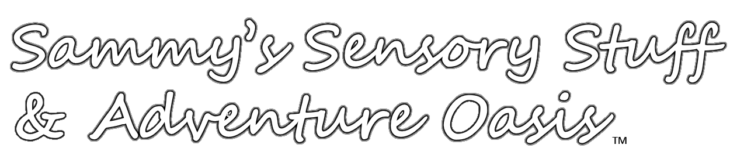
Sammy’s Sensory Stuff & Adventure Oasis
Release of Liability
Please fill in all information, print as neatly as possible

Name of child 1: __________________________________________________Age: _______
Last First
Name of child 2: __________________________________________________Age: _______
Last First
Name of child 3: __________________________________________________Age: _______
Last First

Address: Street_______________________________________________________________

City____________________________________ State________ Zip___________

Emergency Phone: ________________________ Home Phone________________________

I agree to hold harmless and indemnify Sammy’s Sensory Stuff & Learning Tools, its owners, agents and employees, as well as the equipment manufacturers and distributors for any and all loss or damage I may cause to person or property while engaged in physical related activities, this includes but is not limited to, any and all claims for personal injury, death and/or property damage that may in any way arise out of the use of the equipment, or any equipment, regardless of whether such loss or damage be to myself or to others.

I hereby release Sammy’s Sensory Stuff & Learning Tools, its owners, agents and employees, as well as the equipment manufacturers and distributors, from all liability for damage and personal injuries or death resulting from their own acts of negligence. Understanding that Sammy’s Sensory Stuff & Learning Tools, and its owners, agents and employees, as well as the equipment manufacturers and distributors, are not responsible for the consequences of their own negligence, that is, their failure to use reasonable care in any way in the operation of this rental center as well as in the installation, maintenance, selection, adjustment and use of the park’s equipment. I acknowledge that I am freely and expressly assuming and accepting all risks of property damage, personal injury or death to us while we use the parks equipment and facilities.

I understand and am aware that any physical activity such as playing on playground equipment such as jumping in a crash, using swinging equipment or being exposed to flashing/strobe lights can become harmful if not abided by properly. I understand that participating in activities that involve flashing lights or playground equipment can involve a risk of injury. I herby freely and expressly assume and accept responsibility for all risks of injury or death while persons on this form or any one in trusted in my care are participating in this activity.

I, the undersigned and acknowledge that I have carefully read this agreement (release of liability) and I understand its contents. I understand that my signature below expressly waives any rights I or we may have to sue or collect compensation from Sammy’s Sensory Stuff & Learning Tools, its owners or its employees for any injuries, damages or death to myself or persons listed above.

Parent or Guardian ________________________________________Date______________________

